2 Bring a Sprite into Game Maker
If your project opens with this Welcome Screen, you can look at it, and then just close the Welcome tab to get back to the project.
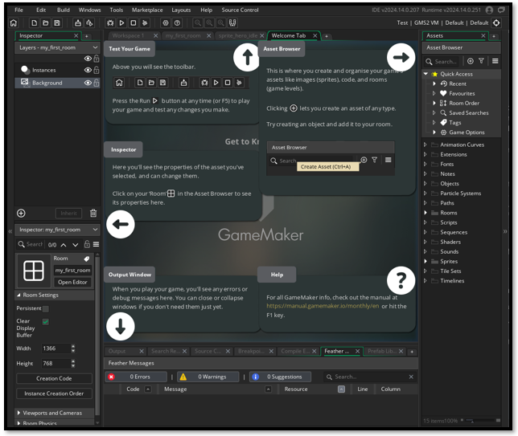

Backgrounds
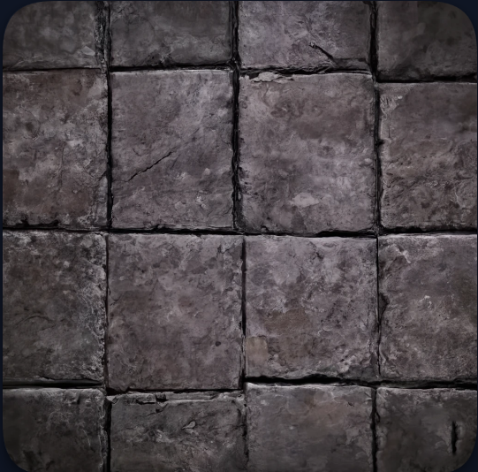
Click on my_first_room, what we named our room, in the asset browser
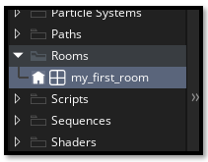
Now look to the left panel to view the size of the room. You will want your floor what ever this size is here.
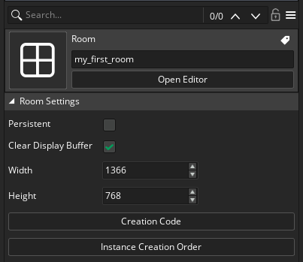
You can just drag your background into the Asset Browser – Sprite. Name it something like background_floor.
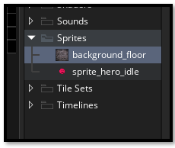
Click on Background in the Layers panel, to be able to open the properties to be able to bring in an image.
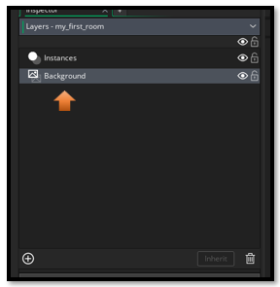
Now look lower down inside of this left side to find the portion that we actually need.

Turn a Sprite into an Object
Last week, we created our Smiley face sprite. This week, we need to change it into an Object before it can properly go into our room. Click on the 3 dots each to find the Sprite folder that we put the floor background in.
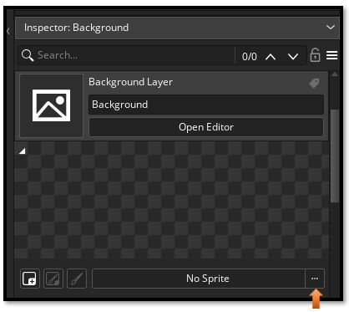
Choose your floor.
